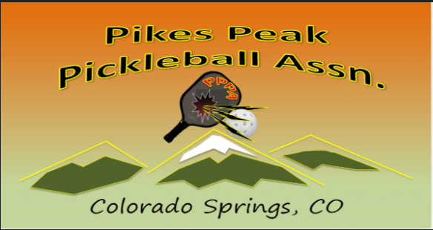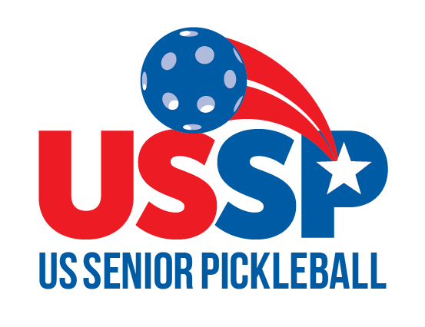
2023 COLORADO OPEN – PIKE PEAK OR BUST
Monument Valley Park, CO Springs, CO
August 11-13 2023
Registration is Open to ALL Ages – NO Memberships required
Men’s Singles/Doubles, Women’s Singles/Doubles, and Mixed Doubles
Age groups 19-34 and 35-49, Skill levels 3.0, 3.5, 4.0, 4.5, 5.0
Senior 5 year, 50-80+ Age/Skill Tournament, Skill levels - 3.0, 3.5, 4.0, 4.5+
$55 registration fee, plus $10 per event, USSP/SSIPA - $10 discount
Registration Opens March 1st on PickleballBrackets.com.
Contact Tim Kuss at tgkuss@comcast.net or
Joe Johnson at joejohnson757@yahoo.com
Go to: PickleballBrackets.com, easy registration and payment process
Create a profile and self-rate or use your UTPR rating
Login, click the icon for USSP Tournaments and register
Generates a “Senior” age-based rating, only senior matches count
Approved USSP Circuit Event/USSeniorPickleball.com

